Date: 30th October 2021

LETTER OF RECOMMENDATION

I am writing to you in support of Angsuman Das and his desire to attend the Erasmus mundus joint Master program. I have known his from July 2021 while he is working with us as Research Intern at RASA Life Science Informatics. I have been consistently impressed by both his attitude towards his work and his performance in the dry lab. He worked in the company's project with patience and utmost dedication. He is hard working and one among the few employees who puts in complete efforts to bring out the best and perfect results of the work assigned to him
He has a highly inquisitive mind with excellent reasoning abilities. His approach towards work is systematic and meticulous. He was able to develop a good understanding of the subject and successfully applied his knowledge to research. He is very much focussed and stable about his goals. He has been found to help other trainees who were actually Masters Students, in understanding difficult concepts about the subject and this shows his profound knowledge. He has excellent writing skills and has written few chapters for the trainee curriculum.
Hence, he would be an asset to your team as he was to us and has my highest recommendation for the Masters program. He has illustrated fantastic research capabilities; hence, I would also recommend him for a research program for more learning . Please let me know if you need further information.

Sincerely,
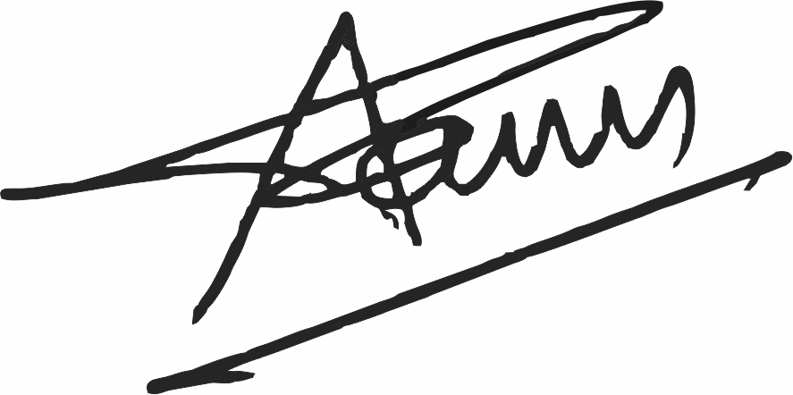
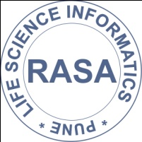

Sameer Chaudhary
Email- ‎aftab@rasalsi.com
CSO & Co-founder
RASA Life Science Informatics, Pune, India

